YOUNG WRITERS PROJECT
WEEKLY CHALLENGES SEPTEMBER 2022 – JUNE 2023

ALREADY FAMILIAR WITH YWP? SKIP THE TOP SECTION, AND GO DIRECTLY TO WEEKLY CHALLENGES BELOW ... YOU CAN RESPOND TO THESE CHALLENGES ANY TIME, REGARDLESS OF DATE ... IF THEY INSPIRE YOU, CLICK THE TITLE AND CREATE!
ABOUT THE CHALLENGES: Young Writers Project’s writing and visual art challenges are meant to inspire and spark creativity every week through the school year. YWP writers, photographers, and artists can respond any time to any of the challenges, but to be considered for publication with our Vermont media partners, responses to the week’s featured prompts are due on Friday of that week. YWP publishes weekly in the Burlington Free Press and VTDigger.org, and monthly in the Rutland Herald and Barre-Montpelier Times Argus. All writing, photos, and art posted on youngwritersproject.org this year – both responses to these challenges and general submissions on any topic – will also be considered for publication in our monthly digital magazine, The Voice, and our annual anthology, published every fall, showcasing the best work of the previous school year.
HOW TO RESPOND TO CHALLENGES: You must have an account on YWP. It's free and easy to sign up. Click on the title of the challenge. The challenge will pop up. Click "Respond." This will open a new blog form in your YWP account that links directly to the challenge. Fill in Title; select a Category; write in the Body section; and SAVE. You can also post images, add audio and video by going to ADD MEDIA on your blog. General submissions: You can post about anything anytime. Log in to your YWP account and Create a Blog Post. Remember to give each post a title, category (poem, nonfiction, visual/photos/art, etc.), and SAVE. No challenge title required.
NEED A PDF VERSION? Download the attachment below.
ALSO:
- NEW THIS YEAR! As part of YWP's new ArtSpace project, we have special art-themed challenges sprinkled throughout the Weekly Challenges during the school year. Watch for them! They're labeled YWP ArtSpace Challenge.
- Try our newsy COMMUNITY JOURNALISM PROJECT CHALLENGES here!
Special thanks for the creativity and heart put into this year’s challenges: YWP summer 2022 intern Charlotte Dodds, YWP publications coordinator Anna Forsythe, and our YWP writers and artists who contributed ideas, themes, and inspiration.

Week 1: Sept. 4-10
No Adjectives: Write about an object, but without adjectives. See how many words you can use!
World Building: Create your own fantasy world – this could be in the form of a drawing, a list of ideas, a long essay-like flowing of thoughts, anything!
Colors: Write about your favorite color. What does it bring to mind?
Portraits: Draw someone, photograph them, or write about them. Who are they? How do you capture their personality in one medium?
Medusa: Write about Medusa, separate from the knowledge you may have about the myth. Who is the person in this image? What is her life like?

Week 2: Sept. 11-17
Exploring: Imagine you are an explorer coming across a completely uninhabited and untouched place. Where is it? What is it like?
Flowers: Go outside and look for a flower, a flowering weed, or even a shrub. What do you imagine this plant would be like as a human?
Crystals: Do you believe in the healing powers of crystals? Why or why not? Write about it!
Lucky: Do you have a lucky number, piece of jewelry, or something similar? What about it brings you luck? What is its meaning?
YWP ARTSPACE CHALLENGE:
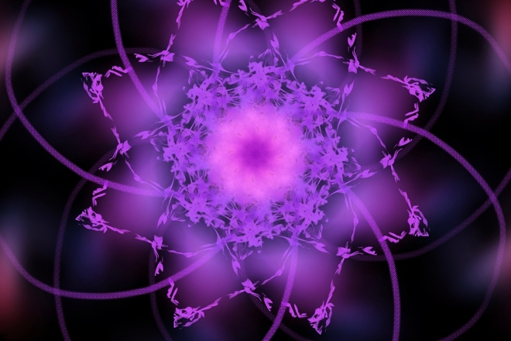Mandala. A mandala (Sanskrit for “circle”) is a geometric design that expands from a single point at the center, with the very act of its creation meant to serve as a meditative tool. Let your mind slow down as you draw or paint your own mandala, or photograph inspiration you find for one in the natural world.

Week 3: Sept. 18-24
Window: Look out (or in) the closest window to you. What do you see? What is going on on the other side? If you can’t see through it well, then what do you imagine might be on the other side?
Creatures: Draw or write about your own magical creature. What does it look like? What is its personality?
Ode to Berries: What is your favorite summer berry? Write an ode to it!
Stargazing: Go stargazing and write, draw, or photograph what you see.
Walk and Write: Go for a walk, find a comfy spot to sit, and write down whatever comes to mind in that moment.

Week 4: Sept. 25-Oct. 1
Sentence Completing No. 1: “If you squint your eyes just enough, you should be able to see …”
Book Reviews: Write a brief review of your favorite book. What about it is so special? Why should others read it?
Sentence Completing No. 2: “We walked for what felt like days, until …”
Library: If you could construct your own personal library, what would it look like? What types of books would its shelves hold?
Inventing: What’s something you think should have been invented, but hasn’t been yet?
YWP ARTSPACE CHALLENGE:
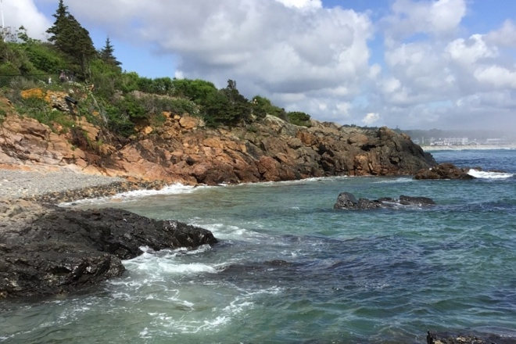 Surreal: Paint or photograph a realistic outdoor landscape, then add a distinctly unrealistic object, person, or creature popping up into the scene. The more out-of-place, the better!

Week 5: Oct. 2-8
Etiquette: Write the new rules of etiquette for modern-day society. What has changed and what has stayed the same?
Sentence Completing No. 3: “Since ____ happened, so many things have changed …”
Hobbies: What’s a hobby that you love? Write all about it.
Personification: Choose two objects and personify them. What do they talk about? What do they do together?
Space: What do you think it would be like to live in space, among the stars? Would you use a personal spaceship to go from planet to planet, or maybe a space shuttle?

Week 6: Oct. 9-15
The Future: What do you envision the future will be like? Narrow in on a specific object and describe how it will evolve over time (e.g. a phone).
Seasons: What is your favorite season? Why?
Memories: Describe or visually represent a favorite memory from childhood.
Routine: What’s a routine in your life? Maybe you eat the same thing for breakfast every morning, or always do one specific skincare routine before bed. Describe this routine and why you like it. And for extra fun, try describing it without using any adjectives.
YWP ARTSPACE CHALLENGE:
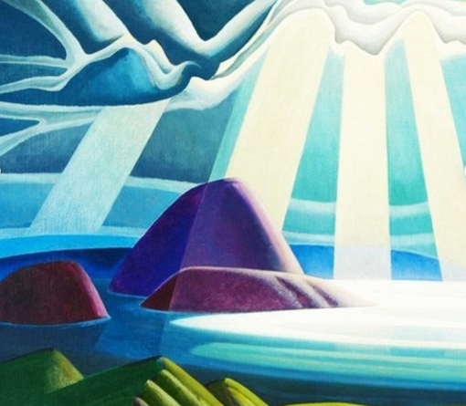Favorite Art: What is your favorite piece of art? Use it as a model for your own artistic creation.

Week 7: Oct. 16-22
Stream of Consciousness: Begin to write exactly what you are thinking, and continue from there. Don’t leave out a single thought! Write for a few minutes, and record everything you think.
Raining... : “It’s raining cats and dogs” is a common idiom that means it is raining hard. What are two other things that could come down with the rain? What is it like when it’s raining “___ and ___”?
Sentence Completing No. 4: “As we walked along the deserted dirt road, I began to realize …”
Sentence Completing No. 5: “She walked slowly, solemnly, with an air of …”
Fairies: Create your own group of fairies – where do they live? Do they tend to any plants or animals? Do they know any humans? Are they good or evil fairies?

Week 8: Oct. 23-29
Sailing: If you could sail anywhere in the world, through any ocean or sea, where would you go? Who would be on your boat with you? Or would you go alone?
Concerts: Have you ever been to a concert? If you've been to multiple, which one was your favorite? What was it like?
Perfect Day: What would your perfect day entail?
Sentence Completing No. 6: “I walked into the nearly-empty diner and was hit by the strong smell of …”
YWP ARTSPACE CHALLENGE:
ROYGBIV: Create a new visual art piece that uses all the vivid colors of the rainbow, without ever depicting a rainbow itself.

Week 9: Oct. 30-Nov. 5
Months: What is your favorite month of the year? Why? What images or memories does it bring to mind?
Sentence Completing No. 7: “When I told my friends I would help them out with something earlier today, I never would have expected that …”
Contrast: Describe two contrasting things (e.g. love and hate, cotton and wool, etc.) or take a photo of these two things. What makes them so different? Are there any similarities?
Potions: If you could make a potion, what would its purpose be, and what would the ingredients be? Who or what would you use it on? What would it smell and look like?
Listen: Listen closely to the noises around you. Are they loud or quiet? Harsh or relaxing? Where are they coming from?

Week 10: Nov. 6-12
Animals: If you could be an animal, which one would you choose? How would you spend your days? How would life be different, and how would it stay the same?
Tradition: In his poem “Tradition,” Wallace Stevens writes, “A poem about tradition could easily be / A windy thing ….” What is tradition to you? Try your hand at writing a poem about this.
Traveling: If you were to travel anywhere right now, where would you go? How would you get there (e.g. plane, bus, train, walking, etc.)?
Sentence Completing No. 8: “‘You need to slow down,’ I say, trying to decipher what it is that my friend ___ is saying …”
Music: What’s your favorite kind of music? What about it draws you in? Describe it, or draw how you feel when you hear it.
YWP ARTSPACE CHALLENGE:
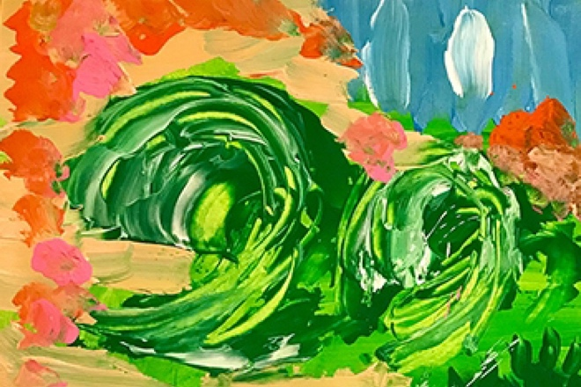Fingerpaint: Who says you’re too old for fingerpaint? We weren’t aware of any such age restriction! Alternatively, work with crayons, markers, glitter, or any other medium meant only for “kids.”

Week 11: Nov. 13-19
Collections: Do you collect anything? If so, why? How many do you have? What do they look like?
Sentence Completing No. 9: “I walked away from that house as fast as I could, my heart racing …”
Garden: Imagine you are in a beautiful garden. What does it look like? What plants are there? Are there any animals? Where is this garden located?
Short Story No. 1: Write about a young child who has been separated from their parents. Where is this located? How did this happen? How can this be resolved?
Short Story No. 2: Write a love story about two bugs – or two animals of any kind – who meet by chance and fall for each other. How do they meet? Where do they go on their first date? What attracts them to each other?

Week 12: Nov. 20-26
Hope: Emily Dickinson famously wrote, “Hope is the thing with feathers / That perches in the soul, / And sings the tune without the words, / And never stops at all.” What do you think of this? Do you agree? What is hope to you?
Eye: Write from the perspective of an eye – maybe you are trapped in a glass jar, or are the glass eye in someone’s head, or are the single eye of the cyclops. What is it like to be the eye?
Short Story No. 3: Write from the perspective of a forgotten doll. What is the story arc going to be?
Proud: Think of a time you felt proud. Were you proud of yourself, or another person? What was it like? Why were you proud?
Veggies: What is a vegetable you really don't like – or one you love? Write an ode to the veggie.
YWP ARTSPACE CHALLENGE:
​Mural: Your parents have just given you carte blanche to paint a mural in your bedroom – anything goes. Give us the mock-up.

Week 13: Nov. 27-Dec. 3
Formatting: Free write about whatever is on your mind right now, but play with the line formatting. Maybe a certain line needs an extra indent, or there needs to be a new stanza over there, or the lines need to run off of the page to help get your meaning across.
First Initial: Use your first initial to write a poem full of alliteration. How many words can you think of that begin with the same letter, and make at least some sort of sense together?
Sentence Completing No. 10: “I rolled over in my bed, finding myself tangled up in bedsheets …”
Plants: Do you care for any plants? What kinds? Write about them, photograph them, draw them, paint them, etc.!
Short Story No. 4: Write your own fairytale!

Week 14: Dec. 4-10
Embarrassed: When was a time you were embarrassed? What happened, and was there a resolution?
Boredom: What makes you bored? What do you do to cure this boredom?
Superhero: If you were a superhero, what superpower would you want? What would your superhero name be, and how would you use your superpower to help people?
Short Story No. 5: Write a story about time traveling – what would happen if you were suddenly sent back in time for seemingly no reason?
Short Story No. 6: Write about someone who is the Ruler of the Universe. What is it like to be them? What is their daily life like? Are they good at being the Ruler of the Universe?
YWP ARTSPACE CHALLENGE:
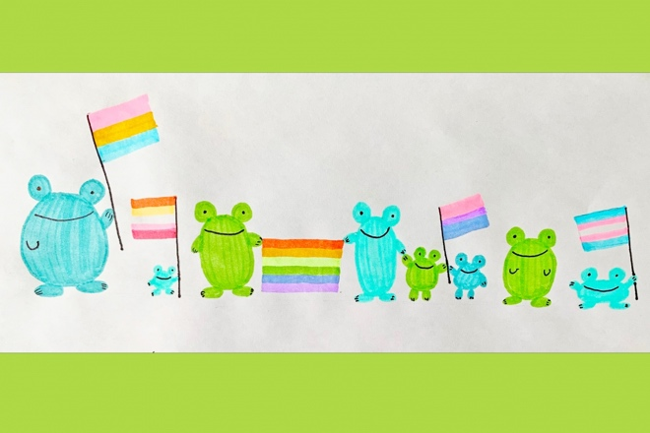 Sticker: We’ve all seen those stick-figure representations of someone’s family on the back of their car – maybe your family even has one! Draw the updated, elevated version of your biological or chosen family as a cartoon bumper sticker.

Week 15: Dec. 11-17
Sentence Completing No. 11: “When I opened my eyes, I saw that my body was no longer mine, but …”
Clouds: What would it be like to live among the clouds, or better yet, to be a cloud?
Short Story No. 7: Write about someone who is the complete opposite of you in every way. Think about the main issue that this story could have, and how this person might resolve that issue.
Reality TV: Create your own Reality TV show. What is its purpose? Who’s on the show?
Decade: If you could go back in time to any decade, which one would you choose? Why?

Week 16: Dec. 18-24
Book Cover: Design your own book cover. This could be a collage, painting, drawing, anything!
Saints: Create your own saint. What, or who, are they the saint of? What do they look like? What miracle gave them their sainthood?
Sentence Completing No. 12: “The air was cold and the wind blew harshly as we walked along the …”
Winter: How do you feel about winter? What is your favorite aspect of winter? Least favorite?
​YWP ARTSPACE CHALLENGE:
Art Critic: Write an appreciation of a piece of art that you admire. Explain why and how this piece affects you.

Week 17: Dec. 25-31
Short Story No. 8: Write about someone who comes home for the holidays, only to rediscover the magic in their family home that they believed in as a child.
Cozy: What are cozy things to you? What makes you feel all warm and cozied-up? Write about it!
Ode to Food: Write an ode to your favorite foods. How often do you get to have them? Why are they so good? Do you have to prepare them, or do you buy them already made?
Excitement: What’s something you’re excited for this week?

Week 18: Jan. 1-7
Resolutions: Do you believe in making New Year’s resolutions? Why or why not? If you do, then what resolution(s) are you making this year?
Trees: If you were to name a tree that embodies your personality, which tree would you choose? Why?
Dreams: What is the last dream you remember having? Maybe it’s from last night, or maybe it’s from a few months ago. If you can’t remember the most recent dream, then what’s a favorite you’ve dreamed or one that keeps returning to you?
Sentence Completing No. 13: “‘How are you?’ I say. 'Well,' …”
Book Plot: If you were to write a book right now, what would it be about? Who would it be about? What genre would it be?

Week 19: Jan. 8-14
Favorite Song: Do you have a favorite song? If so, why does it appeal to you so much? What is it about? How does it make you feel?
Short Story No. 9: Write about someone who embarks on a quest to learn how to sail.
Rain or Snow: Do you prefer rain or snow? Why? Write an ode to whichever weather you enjoy more!
Short Story No. 10: Write about someone who is trapped in an empty castle with no exits.
Birds: What would it be like to be a bird? Where would you fly to?
YWP ARTSPACE CHALLENGE:
Pet Portraits: Draw, paint, or use a camera to capture the idiosyncrasies of your pet(s).

Week 20: Jan. 15-21
Message in a Bottle: You are trapped on a deserted island in the middle of the ocean, but you have access to a glass bottle, paper, and a pen. What do you write on the paper?
Palmistry: What do you imagine the lines on your hand mean? This doesn’t have to follow any rules of palm reading – make up your own predictions!
Sentence Completing No. 14: “The sun was cold, shining through the winter air and onto the glistening snow …”
Short Story No. 11: Write about two skeletons who are good friends and go on adventures together.
Pets: If you (or someone you know) has a pet, spend some time following them around throughout their day. What do you notice? What do they spend their time doing?

Week 21: Jan. 22-28
Birthday: What do you want to do for your next birthday? Or a friend’s birthday? Do you like to have a big party or do something small?
Bedroom: Think about what your dream room would be like (or maybe you already have it!). What do the windows look out on? What kind of bed do you have? Is the room big or small? Would you have lots of decorations, or go for a more minimalist vibe?
Short Story No. 12: Write about someone who goes on an exciting trip – one that they’ve been waiting for their whole life. Who are they going with? Or are they alone? Where are they going? What will they do there? Are they flying, or using some other mode of transportation?
Rainbow: If you could follow a rainbow to the pot of gold at the end, what would be in your pot of gold?
Last Name: What does your last name mean? If you don’t know, then what would you like it to mean?
YWP ARTSPACE CHALLENGE:
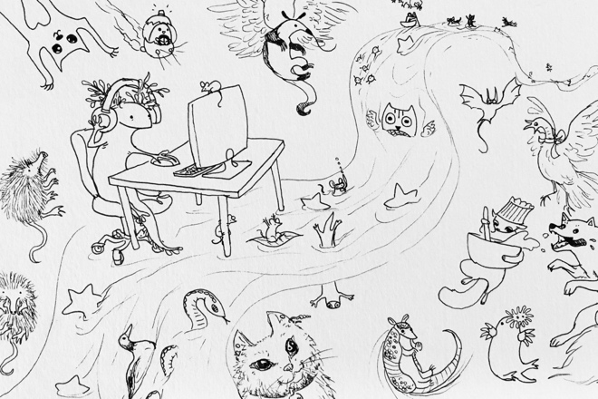Coloring Book: Adult coloring books are having a moment right now, with new studies lauding the activity as a form of mindfulness and many artists jumping on board. Using one color, outline a detailed scene meant to be colored in. Share it with us on YWP!

Week 22: Jan. 29-Feb. 4
Postcard: Write a postcard to someone as if you are traveling far away.
Sentence Completing No. 15: “He stood up and walked over to the window, where the snow was coming down hard …”
Hot or Cold: Do you prefer hot or cold weather? Why?
Hot Air Balloon: Use this as a brain dump: Imagine you are sending all of your pestering thoughts away in a hot air balloon. Which thoughts will you send to float away from you?
Favorites: Write a poem about all your favorite things. There’s no limit to this – favorite park, room, planet, musical instrument, candle scent, poster, sweater, artist, plant, anything you can think of that you love!

Week 23: Feb. 5-11
Look Around: Where are you right now? Write down everything you can think of to describe the space you’re in. Use as many metaphors and similes as possible.
Short Story No. 13: Write about someone who has the ability to read minds.
Short Story No. 14: Write a murder mystery.
Drawer: If you could only use one small drawer for your most precious belonging(s), which one(s) would you choose to put in the drawer and why?
YWP ARTSPACE CHALLENGE:
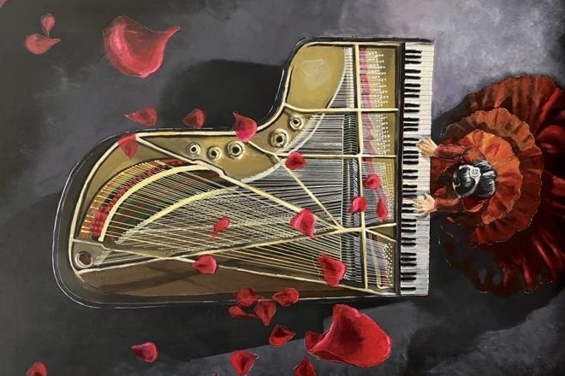Pianist: “Beneath My Fingers,” by YWP's Moonsand, communicates a great intensity of passion that would no doubt swell up in the hearts of all concert-goers were the subject a real person. Depict with art or describe with words the emotional journey of the audience that the pianist looks out on.

Week 24: Feb. 12-18
Love: In honor of Valentine’s Day, what is love to you?
Sentence Completing No. 16: “Slowly, with careful movements, I poured the tea into our mugs while …”
Accomplishments: What’s something you’ve always dreamed of doing? Why? Do you think you will do it one day?
Short Story No. 15: Write about a huge storm that comes through a small town.
Record Player: Write from the perspective of a record player – whose house are you in? Or maybe you’re in a store? What records do you normally play?

Week 25: Feb. 19-25
Sentence Completing No. 17: “I got up from my desk to stretch for a bit after working on ____ for so long …”
Sunrise: Have you ever woken up early to watch the sunrise? If so, what was it like?
Short Story No. 16: Write about someone who has terrible sleepwalking issues.
Crow: Write from the perspective of a crow. What do you do for fun? Do you fly with lots of other crows? Do you have any close friends in particular, or are you a more solitary crow?
Advice: Give us some advice! What’s something you can offer a little wisdom on?
YWP ARTSPACE CHALLENGE:
Meal: Draw, paint, sculpt, or photograph your favorite food or meal.

Week 26: Feb. 26-Mar. 4
Snow: Write an ode to snow, the true marker of winter!
Sentence Completing No. 18: “The other day, I was biking down my street, when …”
Ladders: What would it be like to have to climb up ladders for the rest of time?
Ghosts: Write about ghosts who hang out in their graveyard together. Do they like each other? What time periods are they from? What do they do for fun?
New Month: What are you excited for in this new month?

Week 27: Mar. 5-11
Sunshine: Do you prefer a sunny or cloudy day? Why? How does it make you feel?
Sentence Completing No. 19: “Sometimes I wonder what it would be like if I had the courage to make a change in my life …”
Queens and Kings: Pretend you are royalty in a fairytale. What kingdom do you rule over? Do you have any rivals? What does your castle look like? Do you like being a ruler or would you rather have a low-key, low-pressure existence?
Recipe: Do you have any family recipes, or maybe just a favorite recipe? If it’s not too secret, write a description of you making this recipe (this isn’t copying and pasting the recipe, but more of a scene of you in the kitchen, cooking up something delicious!). You can add the recipe to the end of this, too.
Shoes: Shoes (unless you go barefoot) travel everywhere with us. Do you have one specific pair of shoes? What is your dream pair of shoes? How long have you had your current favorite pair of shoes?

Week 28: Mar. 12-18
Dictionary Poem: Randomly flip to six different pages in a dictionary (or use this Random Word Generator) and, without looking, put your finger down on the page. Write down whichever word is closest to your finger. Use each of the six words your finger lands on in a poem or short story.
Happy: When was a moment that you felt incredibly, unbelievably happy? What were you doing? What did it feel like?
Movies: Write a review of the most recent movie you saw. Did you like it? Is there anything that needs to be improved? Do you think there will be a sequel? How would you rate it on a scale of 1-5? Is the Rotten Tomatoes score accurate, in your opinion?
Lemon: Write either from the perspective of a lemon or an ode to lemons.
Short Story No. 17: Write about someone who is sick and cannot leave their bedroom (e.g. having Covid). What do they do to pass the time? Do they have a pet, a sibling, a friend to keep them company?
YWP ARTSPACE CHALLENGE:
Magnified: Choose an everyday object to depict in its entirety, then with a magnifying glass or your eyes alone, deliver an accompanying visual study of your object up close. Something textured is encouraged!

Week 29: Mar. 19-25
Bread: Thoughts on bread? Like it, hate it, allergic to it? If you like it, do you use it for sandwiches or toast more often? Or something else? What’s your favorite kind of bread? Write an ode to it!
Spring: Happy first day of spring! What are you excited for in this new season? Or maybe you’re sad to see winter go? Dump all your springtime thoughts right here.
Air: Is there magic in the air around you? If you don’t think so, then what is the air made out of? What’s floating around you right now?
Love List: Write a list of the things or people or places (or everything and everyone in the world) that you love – take this in any direction you would like! Just a list, no explanations needed.
Sentence Completing No. 20: “The room was cold and dark, with broken furniture randomly scattered about …”

Week 30: Mar. 26-Apr. 1
Waves: Imagine you are floating on a boat in the ocean, riding the waves. Is there land in sight? What do you hear? What do you smell and see?
Vacation: Do you have a dream vacation? If so, where is it? Why do you want to go there? What do you want to do there?
Sentence Completing No. 21: “As we swam farther and farther away from the shore, I began to forget that …”
April Fools’ Day: Write a tall tale that is pretty outrageous but still has a hint of believability that could fool your readers into thinking it's true!
YWP ARTSPACE CHALLENGE:
Tattoo: If you were to get a magical tattoo that gave you powers based on its symbolism (e.g. a heart would bring you love), what tattoo would you get and why?

Week 31: Apr. 2-8
Short Story No. 18: Write about a flickering lamp that only wants someone to change their lightbulb, but nobody seems to notice their desperate need for help.
Risks: Do you take risks often? Why or why not? What about taking risks either draws you in or pushes you away?
Sentence Completing No. 22: “When I woke up, it took me a second to realize that I was not in my own bed, but in …”
Misty Morning: Write about taking a boat out on a misty lake in the early morning.
Sentence Completing No. 23: “I stumbled out into the light, only to find …”

Week 32: Apr. 9-15
History: If you could rewrite history, what would you change and why? How would things be different?
Dresser: There is a large, old dresser in front of you. It seems to hold something otherworldly. Do you investigate? If so, what do you find?
Three Wishes: If you were granted three wishes, what would you wish for? Why? Would you use all three wishes?
Private: If you could have your own private something, what would that something be? Perhaps a beach, or a ski mountain, or a forest? What do you want all to yourself?
YWP ARTSPACE CHALLENGE:
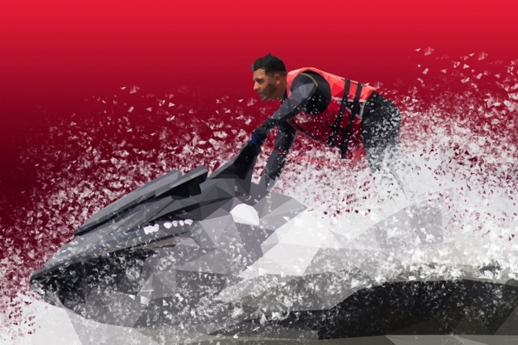Movement: Evoke a sense of movement in your next visual art or photography piece. A vibrating hummingbird? A steamy salsa routine? A Six Flags coaster on its final climactic dive?

Week 33: Apr. 16-22
Object: What is an object near you? Describe it without ever naming it.
Parents: Write an ode to whoever raised you!
Textures: What is your favorite texture? Least favorite? One you’ve never felt? Describe them all.
Author: Who is your favorite author? Write a poem, paragraph, short story, anything, in their style of writing!
Short Story No. 19: Write about a group of turtles on a mission. What will you decide their mission is?
YWP ARTSPACE CHALLENGE:
Captions: Caption an old or entirely new photograph/visual art piece in 3-5 distinct and evocative ways to encourage your viewer to consider it from multiple perspectives.

Week 34: Apr. 23-29
Sentence Completing No. 24: “She is fiery red, with her scales burning up and her horns …”
Snow White: Write your own take on Snow White and the Seven Dwarves.
Place: Do you prefer a small town or a big city? Or maybe something in the middle? Why?
TV Show: If you were to direct a TV show, which one would you choose? Or maybe you would write your own?
No “A”: Free write anything you want, but don’t use the letter “A” at all!

Week 35: Apr. 30-May 6
Beach: Describe your perfect beach day. What do you like to do? Do you swim, walk the shore, read? Write to engage all of your readers' senses.
Short Story No. 20: Write about someone who goes on an adventure in the sea.
Eavesdrop: Listen around your house (or wherever you are right now!) to what you can hear. Write a story out of what you pick up on.
Short Story No. 21: Write about someone who has a terrible, life-altering phobia of something that is commonly accepted as cute.
YWP ARTSPACE CHALLENGE:
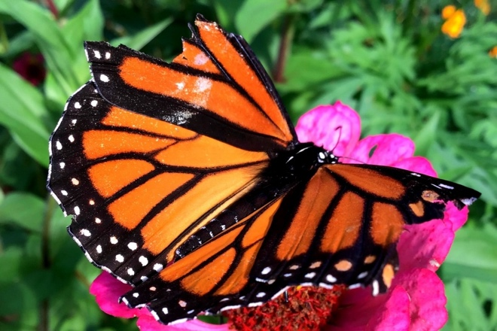Insect: We’ll wager an art teacher has asked you to draw your pet before, but how about a bug? In your own medium, study the intricacies of an insect or arachnid up close.

Week 36: May 7-13
Sentence Completing No. 25: “If I could just see behind that curtain, then …”
Sky: Look at the sky right now. What do you see? What is the weather like? If it’s clear, can you see any incoming storm clouds?
Water: Write from the perspective of water. Are you a pond, a river, a lake, the ocean, or something else entirely?
Fears: What were you scared of as a child? Are you still scared of these things? Do you have any new fears?
Pinterest: Write about someone who is a walking Pinterest board. Which board do they represent?

Week 37: May 14-20
Another Decade: Write something that is based in another time. Which decade will you choose?
Short Story No. 22: Write about an elephant that is on a walk.
Boat: Write from the perspective of a boat. Which body of water does it live in? What kind of boat is it? Who owns it? How old is it? What does it think about being a boat?
Sunset and Stars: Write about watching the sun go down and the stars come out.
YWP ARTSPACE CHALLENGE:
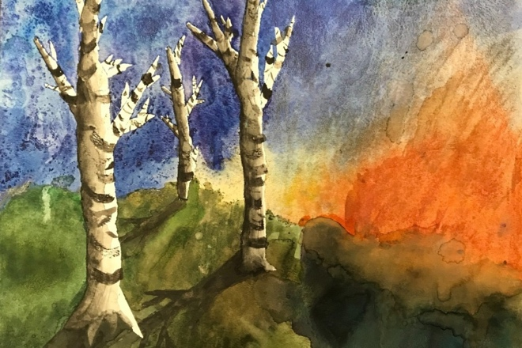Nature: Look at the natural world around you. What do you see? What do you smell? What do you feel? Write about it. Photograph it. Paint it!

Week 38: May 21-27
Sentence Completing No. 26: “The stones on the walkway were smooth and rounded …”
Astronaut: If you could get in a spaceship and go anywhere, would you? If yes, then where would you go? How long would you spend in space?
Short Story No. 23: Write about a scoop of ice cream teetering on top of an ice cream cone. What is this poor ice cream scoop thinking as it wobbles and is about to topple?
Cats: Write from the perspective of a cat. How do you spend your time? Who do you live with? What’s your favorite sleeping spot?
Summer: Write or draw whatever you’re thinking about the end of the school year and the upcoming summer vacation!

